Snub Dodecadodecahedron

Definition
# Source: AI Source: Provided by: [Data Path: Persons Table -> ID Column: 1, Name_En Column: Motasem Essam] -> From: [ChatGPT] on [7/25/2026]
The Snub Dodecadodecahedron is a non-convex uniform star polyhedron belonging to the snub family of uniform polyhedra. It is composed of equilateral triangular faces, regular pentagonal faces, and regular pentagrams.
It has a distinctive chiral structure, meaning it exists in two mirror-image forms: left-handed and right-handed. Unlike the convex Archimedean Snub Dodecahedron, this solid contains intersecting pentagram faces and has a non-convex geometry.
It is classified as U₄₀ in Maeder's classification of uniform polyhedra. It is also known by the name Snub Great Dodecahedron.

Geometric Representation
# Source: AI Source: Provided by: [Data Path: Persons Table -> ID Column: 1, Name_En Column: Motasem Essam] -> From: [ChatGPT] on [7/25/2026]
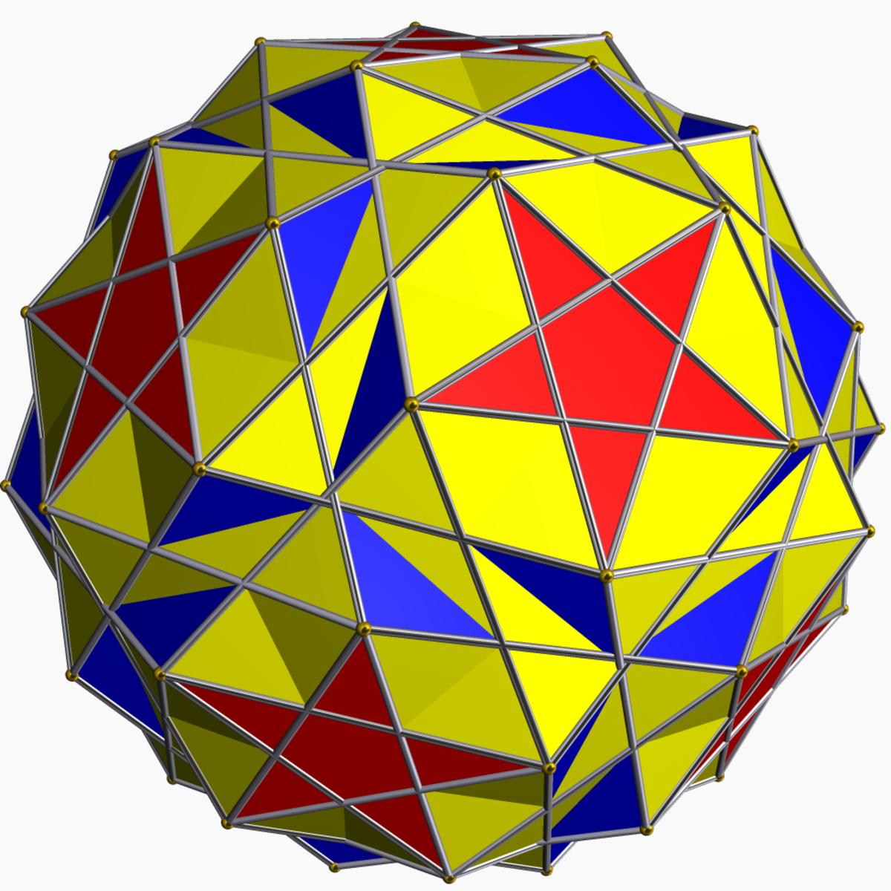

Geometric Structure
# Source: AI Source: Provided by: [Data Path: Persons Table -> ID Column: 1, Name_En Column: Motasem Essam] -> From: [ChatGPT] on [7/25/2026]
The Snub Dodecadodecahedron consists of:
- 60 equilateral triangular faces.
- 12 regular pentagonal faces.
- 12 regular pentagrammic faces.
Its structure is characterized by:
- Intersecting faces and edges.
- A uniform arrangement of faces around every vertex.
- Icosahedral rotational symmetry.
- Chiral geometry with two mirror-image forms.
Its faces are represented by:
- Triangle: $\{3\}$
- Pentagon: $\{5\}$
- Pentagram: $\{5/2\}$
The pentagram is a regular five-pointed star polygon whose edges connect every second vertex of a regular pentagon.

Mathematical Properties
# Source: AI Source: Provided by: [Data Path: Persons Table -> ID Column: 1, Name_En Column: Motasem Essam] -> From: [ChatGPT] on [7/25/2026]
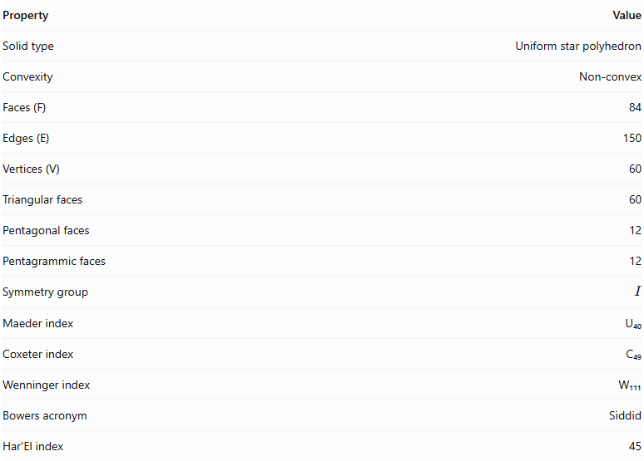
Property | Value
Solid type | Uniform star polyhedron
Convexity | Non-convex
Faces (F) | 84
Edges (E) | 150
Vertices (V) | 60
Triangular faces | 60
Pentagonal faces | 12
Pentagrammic faces | 12
Symmetry group | $$I$$
Maeder index | U₄₀
Coxeter index | C₄₉
Wenninger index | W₁₁₁
Bowers acronym | Siddid
Har'El index | 45

Face Composition
# Source: AI Source: Provided by: [Data Path: Persons Table -> ID Column: 1, Name_En Column: Motasem Essam] -> From: [ChatGPT] on [7/25/2026]
The solid contains three types of polygonal faces.
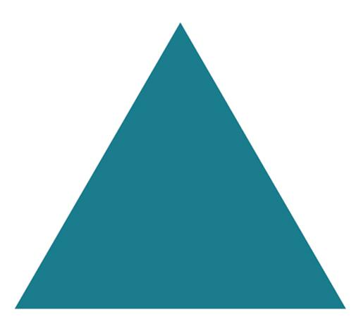

Triangles
# Source: AI Source: Provided by: [Data Path: Persons Table -> ID Column: 1, Name_En Column: Motasem Essam] -> From: [ChatGPT] on [7/25/2026]
3 sides each
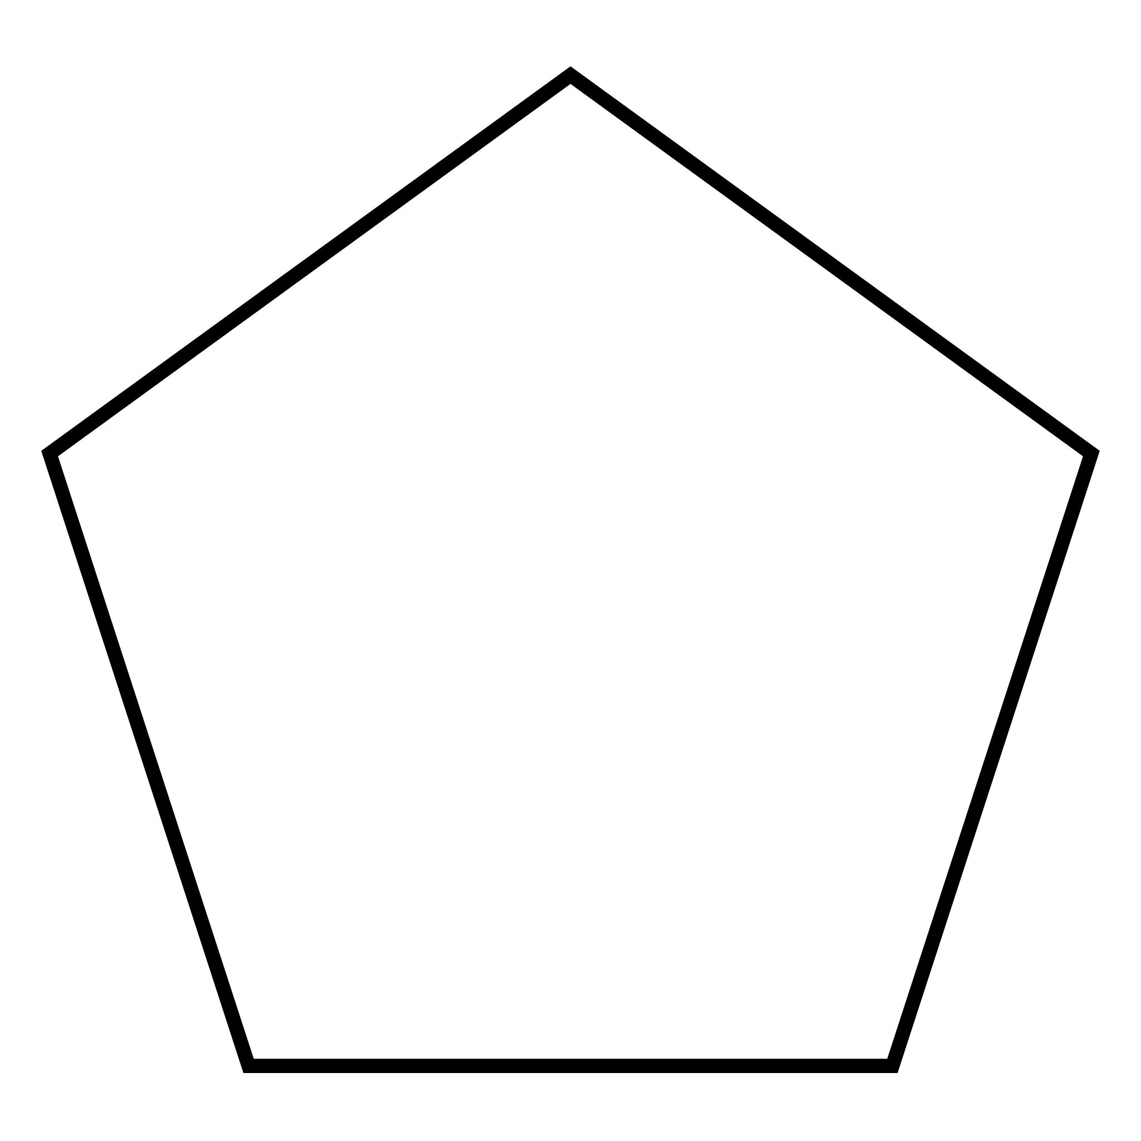

Pentagons
# Source: AI Source: Provided by: [Data Path: Persons Table -> ID Column: 1, Name_En Column: Motasem Essam] -> From: [ChatGPT] on [7/25/2026]
5 sides each
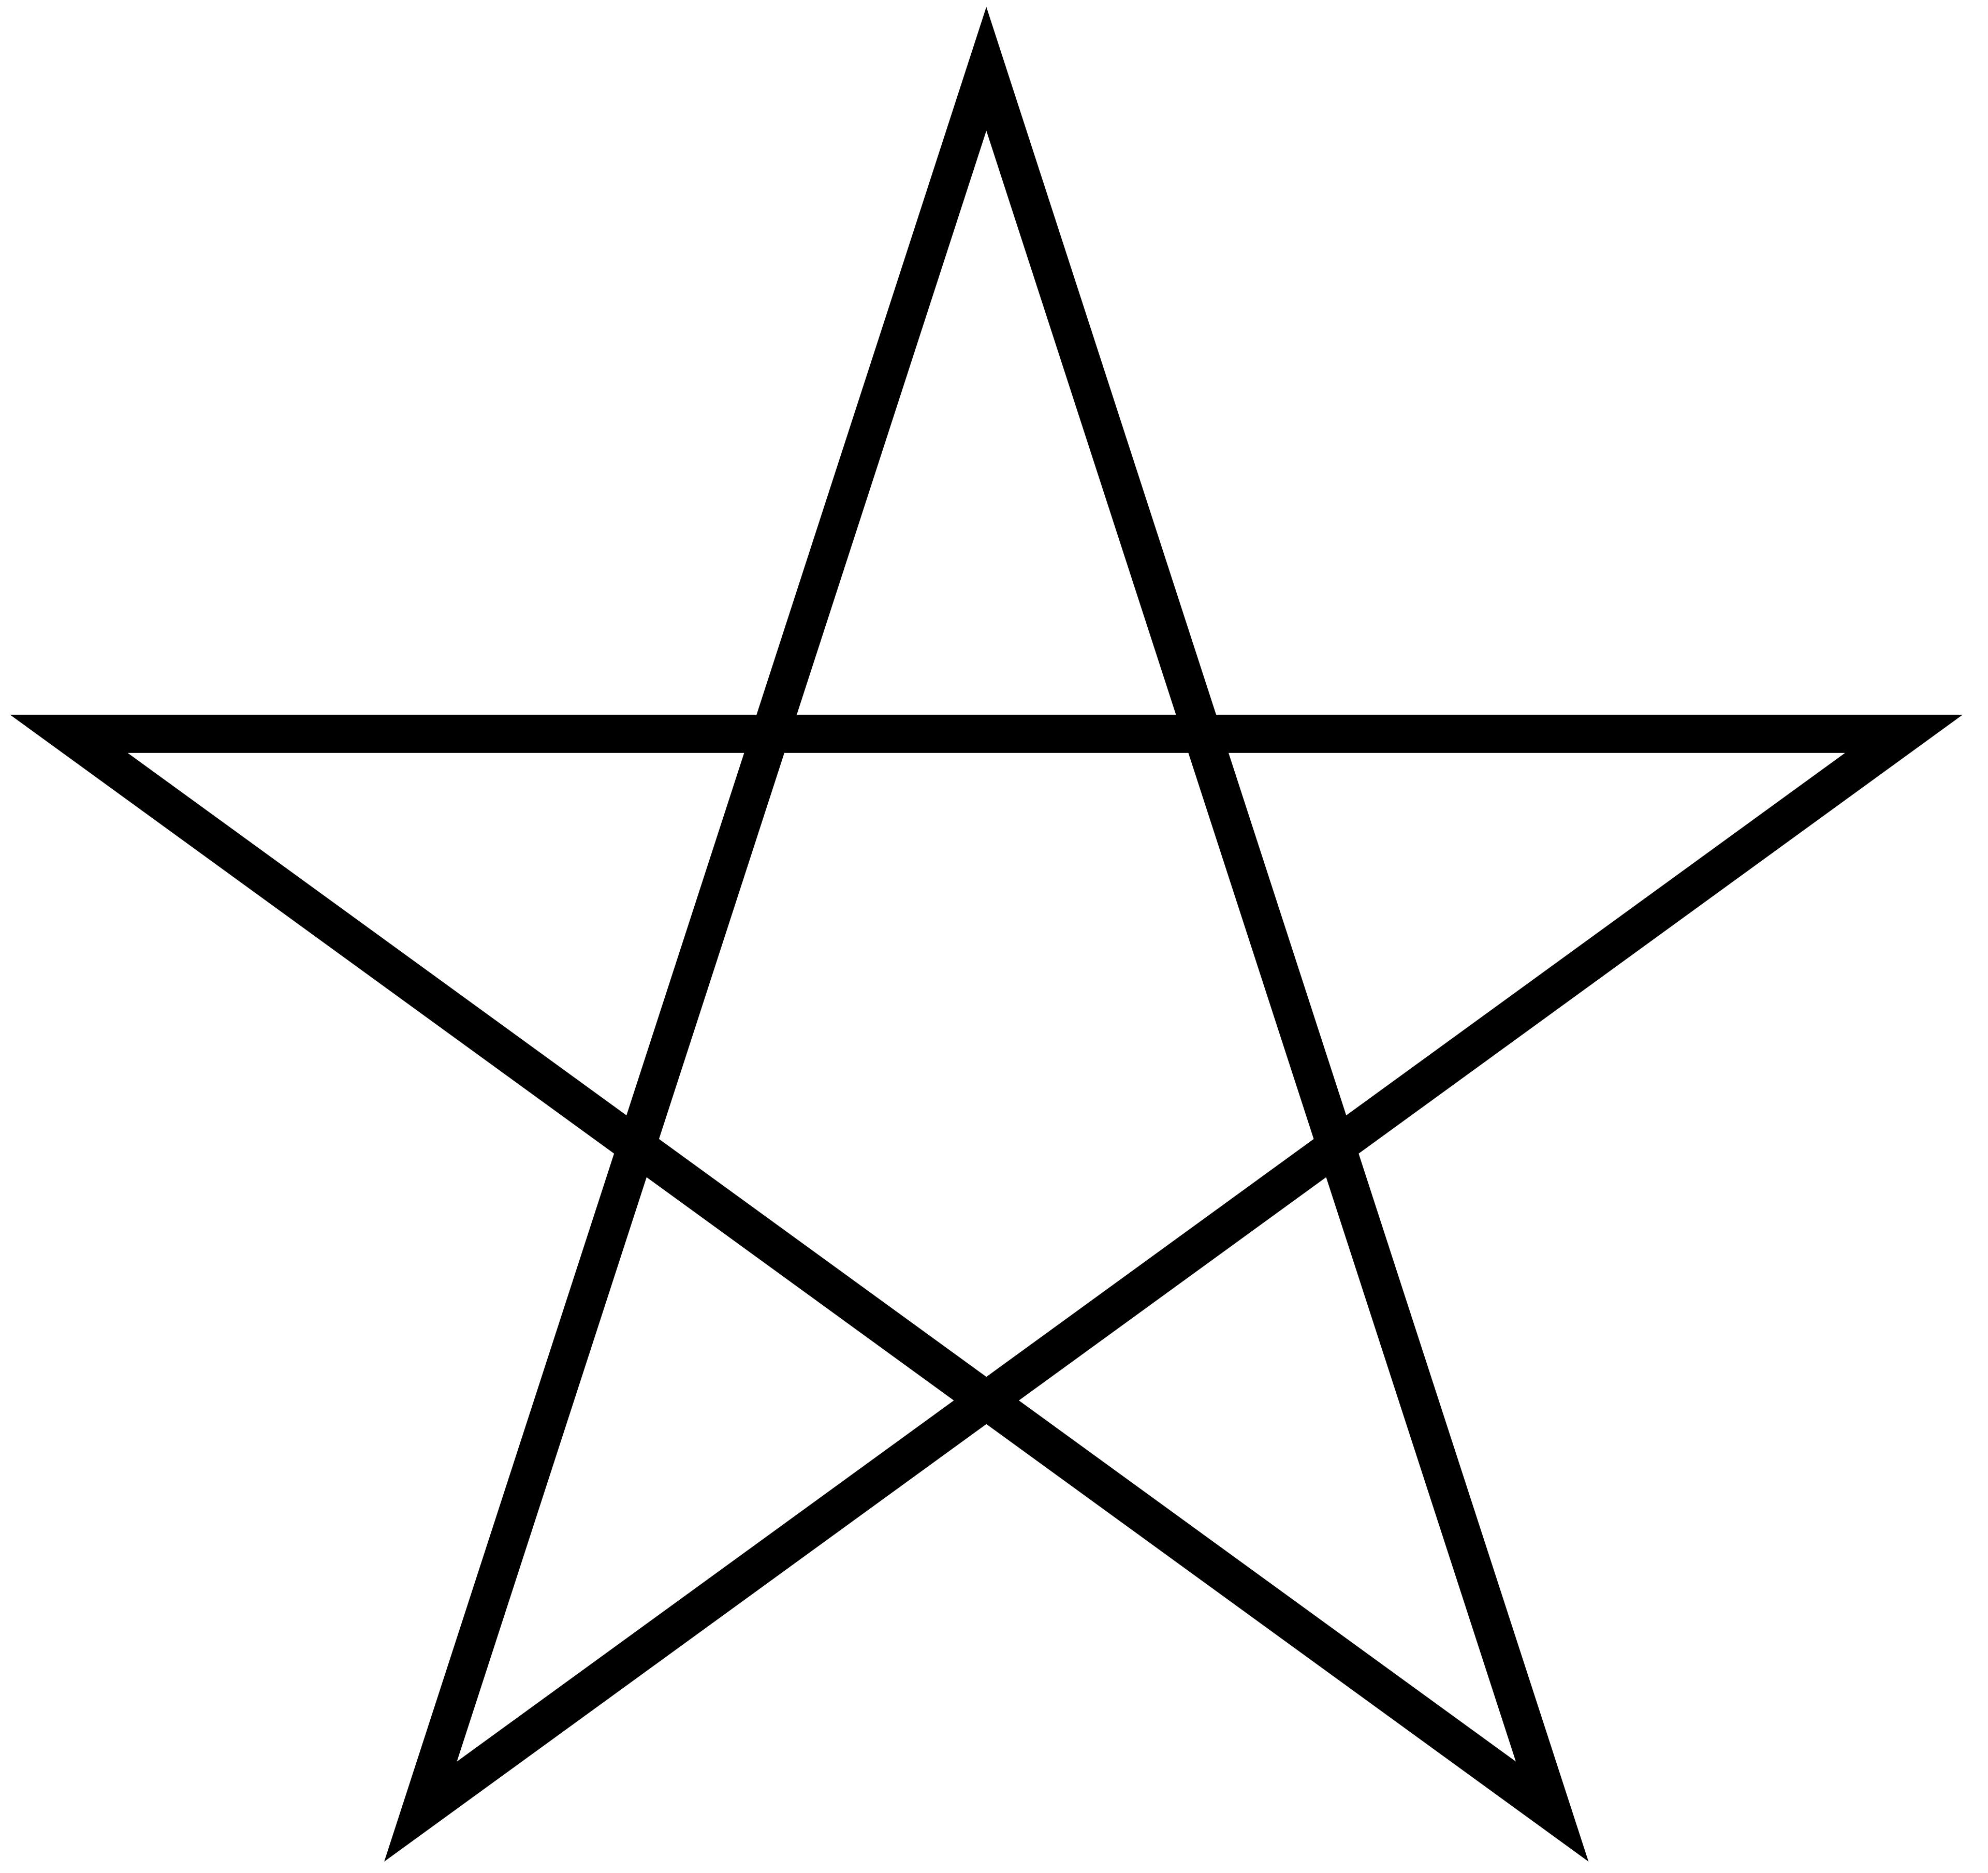

Pentagrams
# Source: AI Source: Provided by: [Data Path: Persons Table -> ID Column: 1, Name_En Column: Motasem Essam] -> From: [ChatGPT] on [7/25/2026]
5 crossing sides each
The face composition is:
$$F=60+12+12=84$$
Using polygon notation:
$$\boxed{60\{3\}+12\{5\}+12\{5/2\}}$$

Vertex Configuration
# Source: AI Source: Provided by: [Data Path: Persons Table -> ID Column: 1, Name_En Column: Motasem Essam] -> From: [ChatGPT] on [7/25/2026]
The vertex configuration describes the arrangement of faces surrounding each vertex.
For the Snub Dodecadodecahedron, it is:
$$\boxed{3.3.\frac{5}{2}.3.5}$$
This means that five faces meet at each vertex, in the following sequence:
- Triangle $\{3\}$
- Triangle $\{3\}$
- Pentagram $\{5/2\}$
- Triangle $\{3\}$
- Pentagon $\{5\}$
The same local arrangement occurs at every vertex, which is an essential property of a uniform polyhedron.

Construction
# Source: AI Source: Provided by: [Data Path: Persons Table -> ID Column: 1, Name_En Column: Motasem Essam] -> From: [ChatGPT] on [7/25/2026]
The Snub Dodecadodecahedron is generated through a Wythoff construction associated with icosahedral rotational symmetry.
Its Wythoff symbol is:
$$\boxed{| 2 \frac{5}{2} 5}$$
It is also described by the snub Schläfli notation:
$$\boxed{sr\{\frac{5}{2},5\}}$$
The construction produces the characteristic combination of triangles, pentagons, and pentagrams.

Geometric Dimensions and Formulas
# Source: AI Source: Provided by: [Data Path: Persons Table -> ID Column: 1, Name_En Column: Motasem Essam] -> From: [ChatGPT] on [7/25/2026]
Let $a$ represent the edge length of the regular polygonal faces.
Equilateral triangle
$$A_{3}=\frac{\sqrt{3}}{4}a^{2}$$
Regular pentagon
$$A_{5}=\frac{1}{4}\sqrt{25+10\sqrt{5}} a^{2}$$
Regular pentagram
For a regular pentagram with star-edge length $a$, the signed area can be expressed as:
$$A_{5/2}^{*}=\frac{5a^{2}}{4sin{72}^{∘}}$$
The absolute signed area describes the algebraic area associated with the star polygon's winding. It should not be confused with the sum of the separate regions enclosed by its intersecting edges.
Sum of individual face areas
$$A_{faces}=60A_{3}+12A_{5}+12A_{5/2}$$
This expression sums the individual face areas; it does not represent the exposed boundary area of the intersecting polyhedron.

Euler Characteristic
# Source: AI Source: Provided by: [Data Path: Persons Table -> ID Column: 1, Name_En Column: Motasem Essam] -> From: [ChatGPT] on [7/25/2026]
The Euler characteristic is calculated using:
$$χ=V-E+F$$
Substituting the values:
$$χ=60-150+84$$
$$\boxed{χ=-6}$$
For a connected, closed, orientable abstract surface:
$$χ=2-2g$$
Therefore:
$$g=\frac{2-χ}{2}$$
$$\boxed{g=4}$$
This genus describes the abstract surface topology associated with the polyhedron's face structure.

Symmetry
# Source: AI Source: Provided by: [Data Path: Persons Table -> ID Column: 1, Name_En Column: Motasem Essam] -> From: [ChatGPT] on [7/25/2026]
The Snub Dodecadodecahedron has icosahedral rotational symmetry.
Its rotational symmetry group is:
$$\boxed{I}$$
Its symmetry is chiral, meaning that it does not possess reflection symmetry. Consequently, two mirror-image forms exist:
- Left-handed Snub Dodecadodecahedron
- Right-handed Snub Dodecadodecahedron
These two forms have identical geometric properties but opposite handedness.

Constructing a Snub Dodecadodecahedron

Geometric Instruments
# Source: AI Source: Provided by: [Data Path: Persons Table -> ID Column: 1, Name_En Column: Motasem Essam] -> From: [ChatGPT] on [7/25/2026]
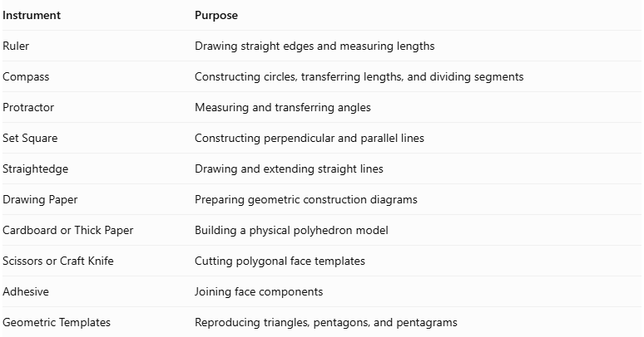
Instrument | Purpose
Ruler | Drawing straight edges and measuring lengths
Compass | Constructing circles, transferring lengths, and dividing segments
Protractor | Measuring and transferring angles
Set Square | Constructing perpendicular and parallel lines
Straightedge | Drawing and extending straight lines
Drawing Paper | Preparing geometric construction diagrams
Cardboard or Thick Paper | Building a physical polyhedron model
Scissors or Craft Knife | Cutting polygonal face templates
Adhesive | Joining face components
Geometric Templates | Reproducing triangles, pentagons, and pentagrams

Instrument-Based Construction Procedures

Method 1: Construction by Snubification of a Rhombidodecadodecahedron
# Source: AI Source: Provided by: [Data Path: Persons Table -> ID Column: 1, Name_En Column: Motasem Essam] -> From: [ChatGPT] on [7/25/2026]
This method uses the Rhombidodecadodecahedron as a geometric starting framework. The snub construction replaces its square-face regions with triangular arrangements and introduces a slight rotational adjustment so that the resulting triangular faces become equilateral. This is a documented geometric relationship between the two uniform polyhedra.
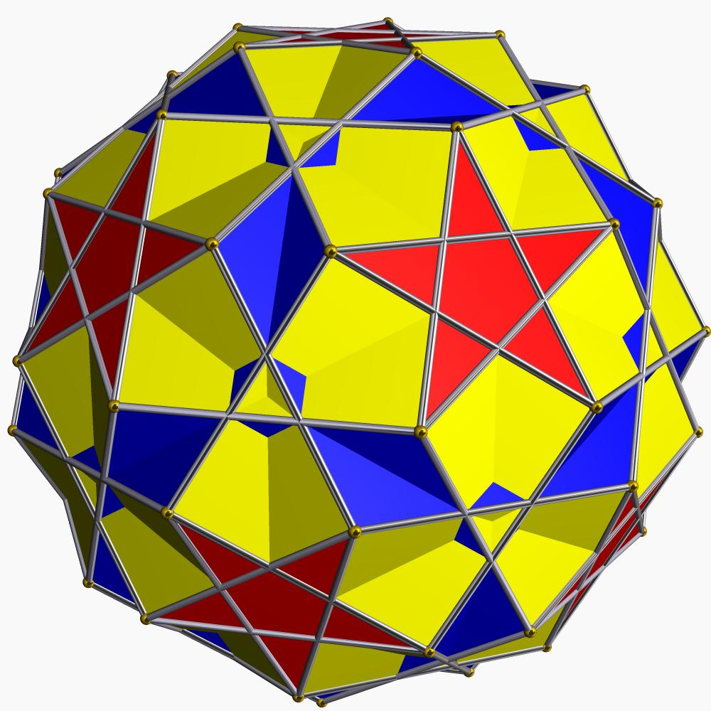
Step 1: Construct the Rhombidodecadodecahedron Framework
- Establish an icosahedrally symmetric reference arrangement.
- Construct the 12 pentagonal and 12 pentagrammic face groups.
- Identify the 30 square-face regions.
- Maintain consistent edge lengths and symmetry throughout the framework.
Step 2: Divide the Square Faces
- Identify the diagonal direction of each square.
- Divide each square into two triangular regions using a straightedge.
- Maintain the same diagonal orientation throughout the construction, following one consistent handedness.
- Repeat for all 30 squares.
Step 3: Apply the Snub Rotation
- Rotate the triangular arrangements slightly relative to the original framework.
- Use a protractor to control the angular adjustment.
- Maintain the same rotational direction throughout the construction.
- Adjust the arrangement until the resulting triangular faces are equilateral.
Step 4: Establish the Final Face Arrangement
- Preserve the 12 pentagonal faces.
- Preserve the 12 pentagrammic faces.
- Complete the 60 equilateral triangular faces.
- Connect the faces according to the Snub Dodecadodecahedron's uniform arrangement.
Step 5: Verify the Construction
- Count the 60 triangular faces.
- Count the 12 pentagons.
- Count the 12 pentagrams.
- Check that the framework contains 60 vertices and 150 edges.
- Inspect the solid to confirm its handedness and non-convex structure.

Method 2: Construction Using Icosahedral Wythoff Geometry
# Source: AI Source: Provided by: [Data Path: Persons Table -> ID Column: 1, Name_En Column: Motasem Essam] -> From: [ChatGPT] on [7/25/2026]
The Snub Dodecadodecahedron is associated with the Wythoff symbol:
$$\boxed{\left| 2 \frac{5}{2} 5\}\right.}$$
This method uses the rotational icosahedral symmetry arrangement and its associated reflection geometry to establish the uniform vertex and face structure.
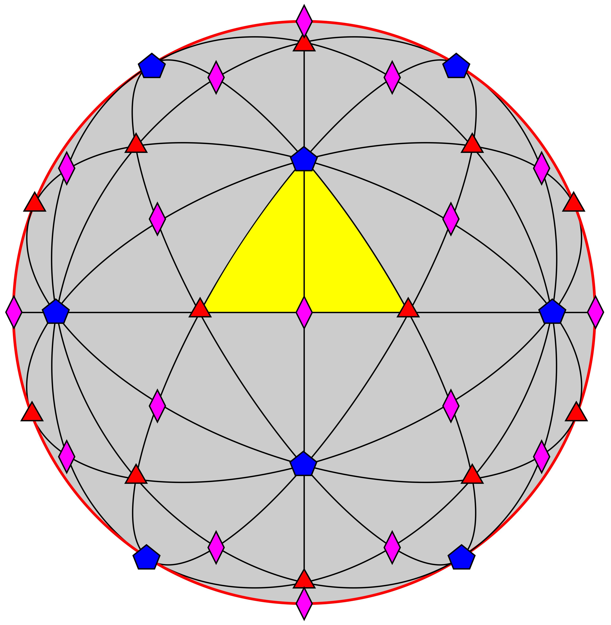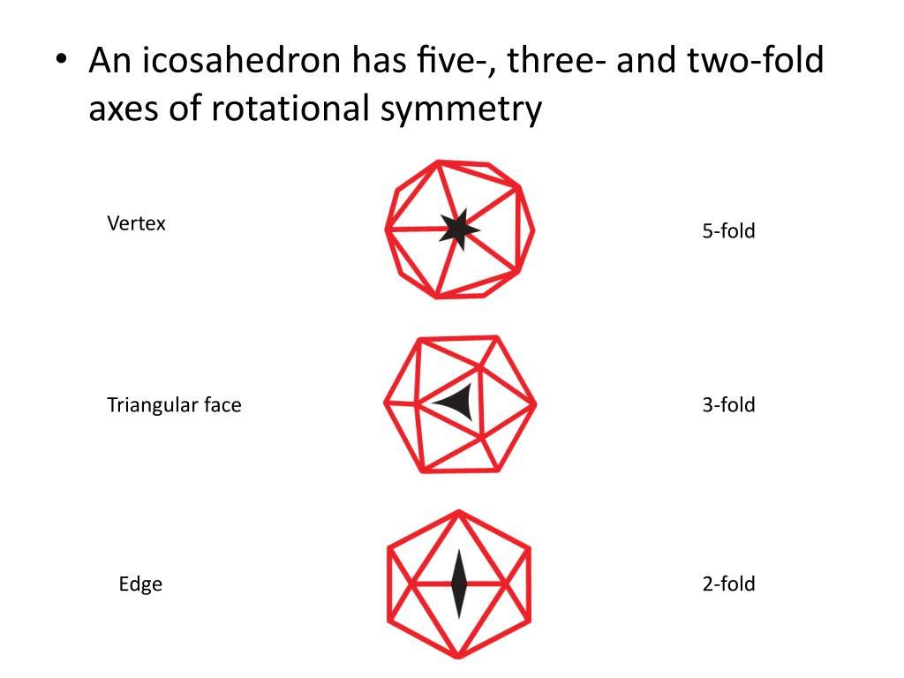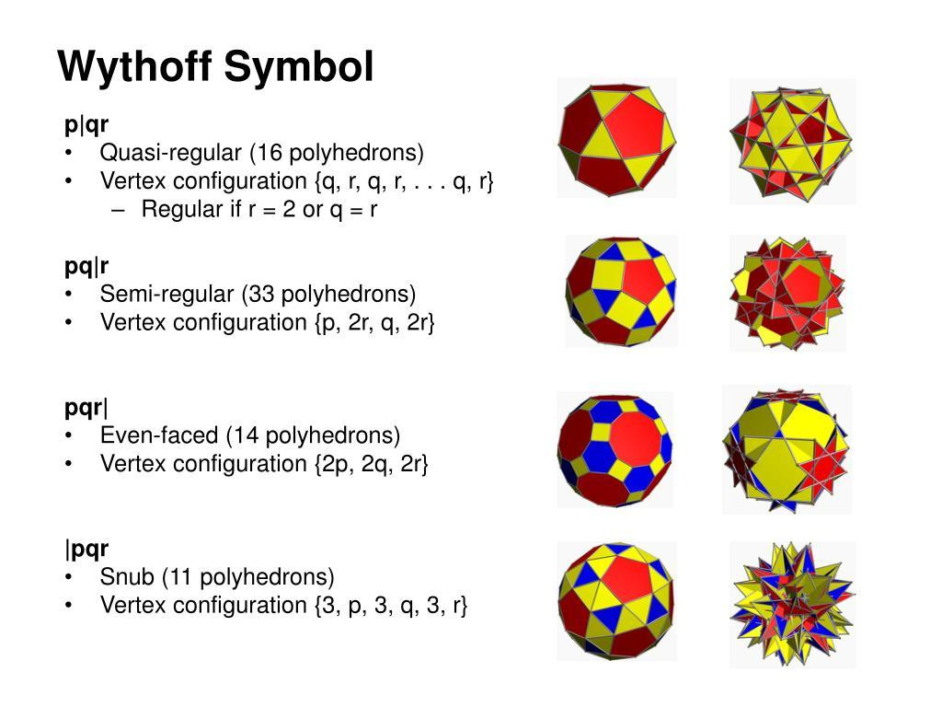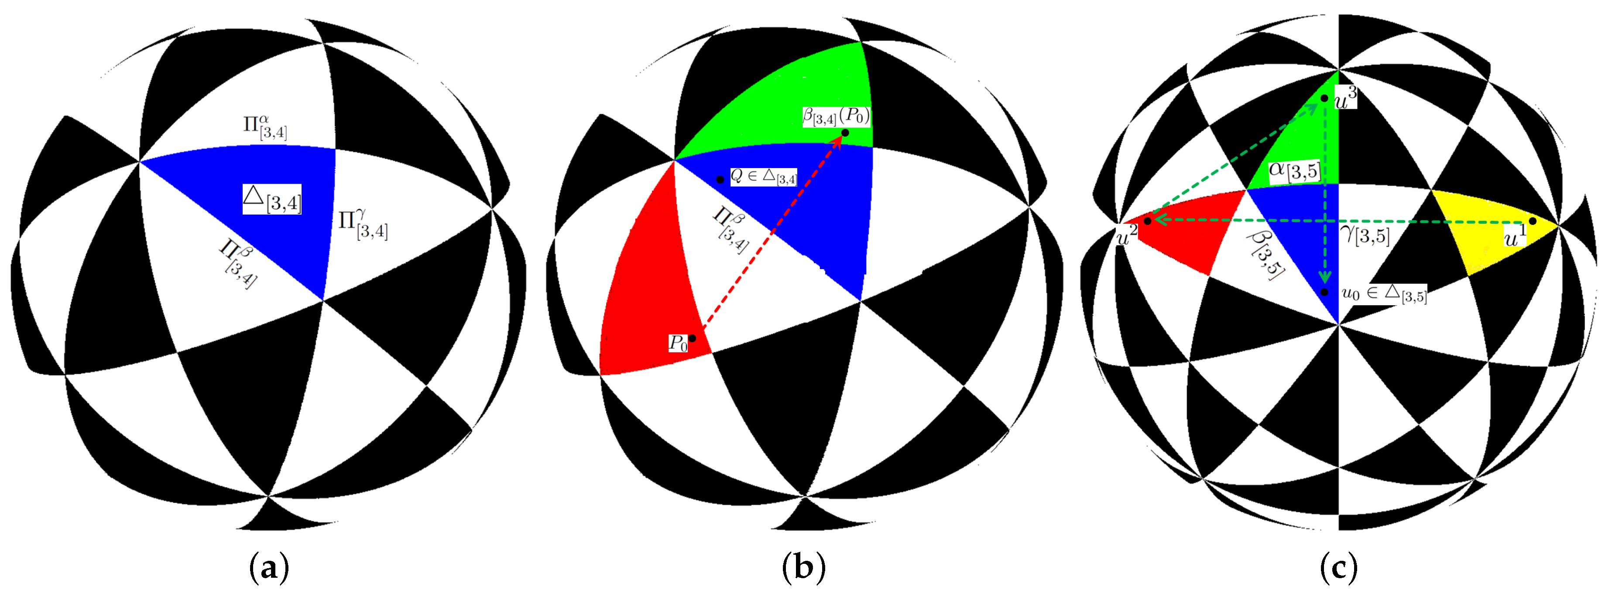
Step 1: Establish the Icosahedral Symmetry Framework
- Construct a regular pentagonal reference arrangement.
- Identify its fivefold symmetry direction.
- Establish the associated threefold and twofold symmetry directions.
- Use geometric reflections and rotations to establish the icosahedral framework.
Step 2: Construct the Fundamental Geometric Region
- Draw the symmetry reference lines.
- Use a protractor to establish the required angular relationships.
- Construct the fundamental spherical triangle or its planar geometric representation.
- Mark the three symmetry boundaries corresponding to the Wythoff arrangement.
Step 3: Establish the Snub Starting Position
- Interpret the Wythoff symbol $\left| 2 \frac{5}{2} 5\right.$.
- Mark the required starting position relative to the fundamental region.
- Transfer the necessary distances with a compass.
- Maintain the orientation required for the chosen handed form.
Step 4: Generate the Symmetry-Related Vertices
- Apply the rotational symmetry operations to the starting construction.
- Repeat the construction through the icosahedral symmetry arrangement.
- Establish all 60 vertices.
Step 5: Construct the Faces
- Connect the appropriate vertices to create 60 equilateral triangles.
- Construct the 12 regular pentagons.
- Construct the 12 regular pentagrams.
- Preserve the correct star-polygon intersections.
Step 6: Complete the Polyhedron
- Connect the 150 edges.
- Verify the vertex configuration.
- Inspect the model from several directions.
- Confirm that the construction has a consistent left-handed or right-handed orientation.
Construction note: The Wythoff symbol specifies the symmetry construction, but a complete physical construction also requires the exact fundamental-region dimensions and starting-point placement. The symbol alone is not a complete set of drawing measurements.

Method 3: Construction Using Polygonal Face Templates
# Source: AI Source: Provided by: [Data Path: Persons Table -> ID Column: 1, Name_En Column: Motasem Essam] -> From: [ChatGPT] on [7/25/2026]
This method is suitable for preparing a physical paper or cardboard model. It requires careful face arrangement because the pentagrammic faces intersect and the polyhedron is chiral.
Step 1: Prepare the Equilateral Triangle Templates
- Construct an equilateral triangle with side length $a$.
- Verify that all three sides are equal.
- Check that each interior angle is ${60}^{°}$.
- Prepare 60 copies.
Step 2: Prepare the Regular Pentagon Templates
- Construct a regular pentagon with side length $a$.
- Divide its circumference into five equal parts.
- Connect the five consecutive vertices.
- Check that each interior angle is ${108}^{°}$.
- Prepare 12 copies.
Step 3: Prepare the Pentagram Templates
- Construct a regular pentagon with side length $a$.
- Label its vertices in cyclic order.
- Connect each vertex to the second vertex ahead.
- This produces the regular pentagram $\{5/2\}$.
- Prepare 12 copies.
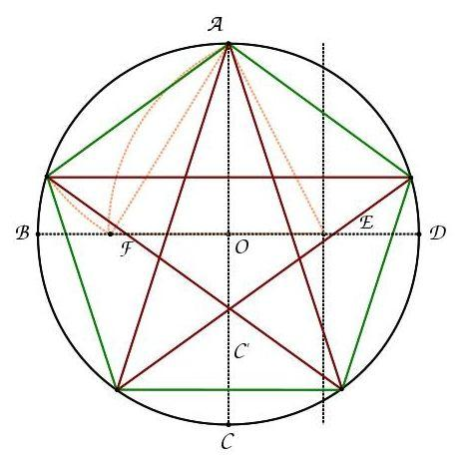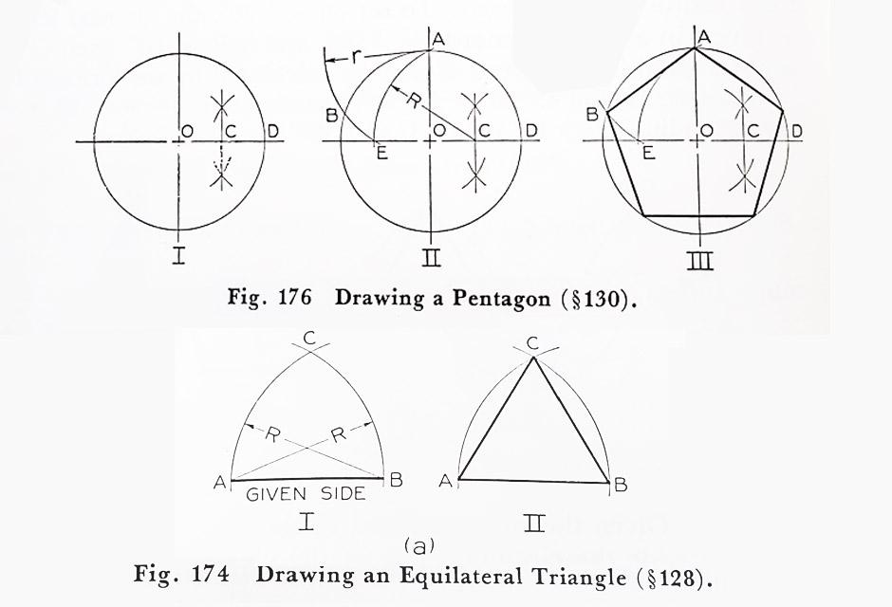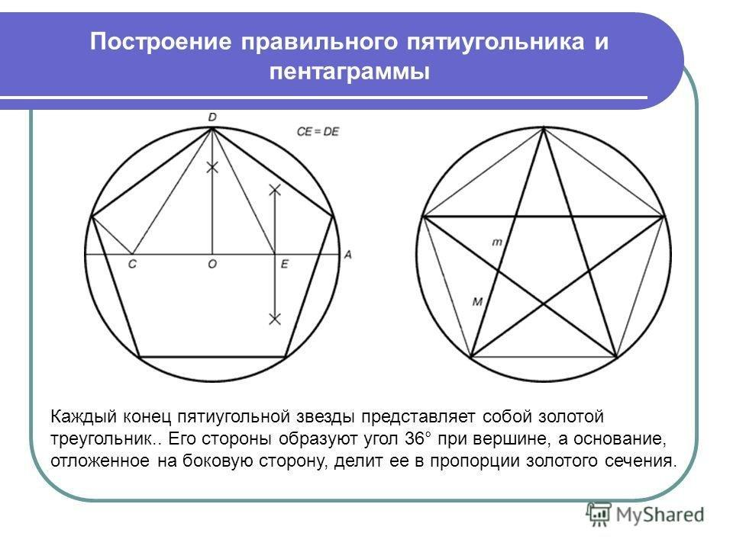
Step 4: Establish the Common Edge Length
- Use the same edge length $a$ for all face types.
- Compare the sides using a compass.
- Correct any differences before assembly.
Step 5: Arrange the Face Templates
- Use an icosahedrally symmetric reference framework.
- Position the 60 triangles, 12 pentagons, and 12 pentagrams.
- Follow the vertex configuration $3.3.\frac{5}{2}.3.5$.
- Choose and maintain one handed orientation.
Step 6: Assemble the Model
- Cut out the polygonal templates.
- Join corresponding edges using tabs or connectors.
- Preserve the required pentagrammic intersections.
- Check the completed model from multiple directions.
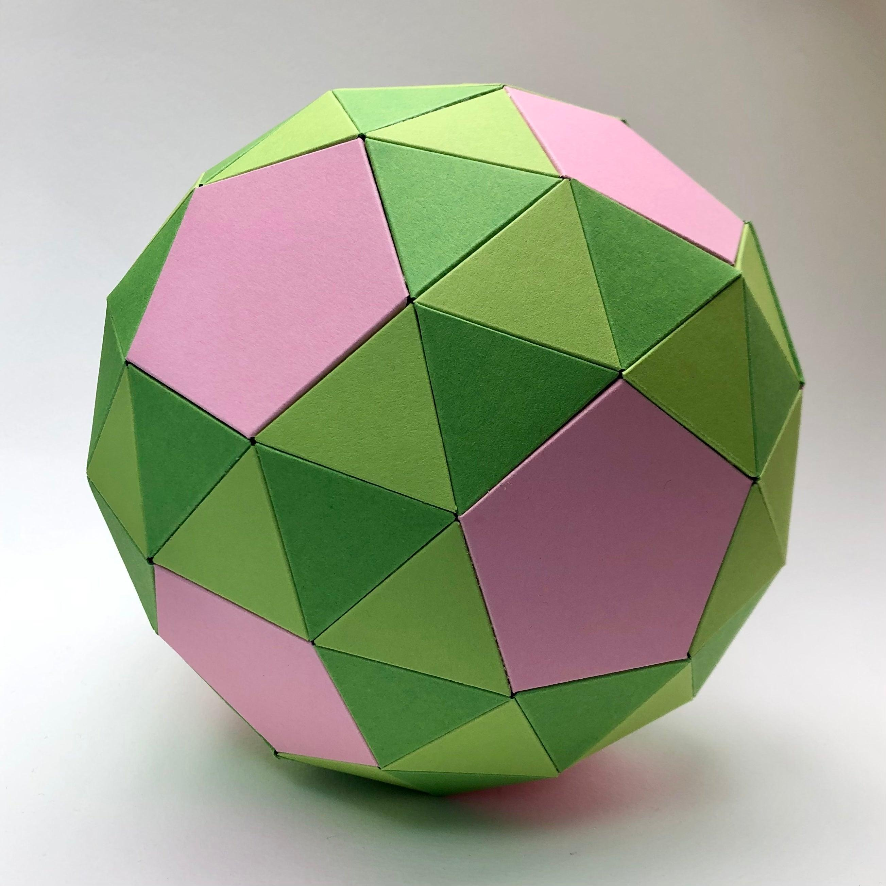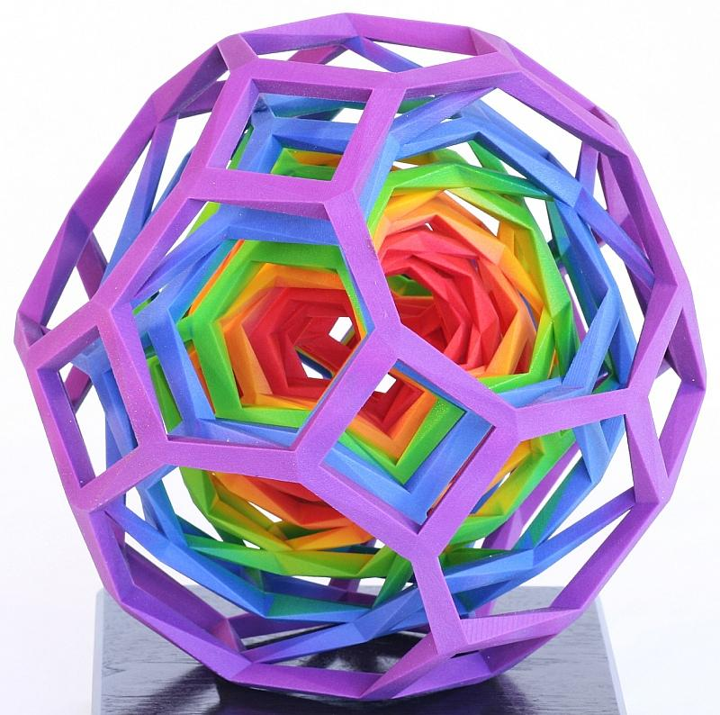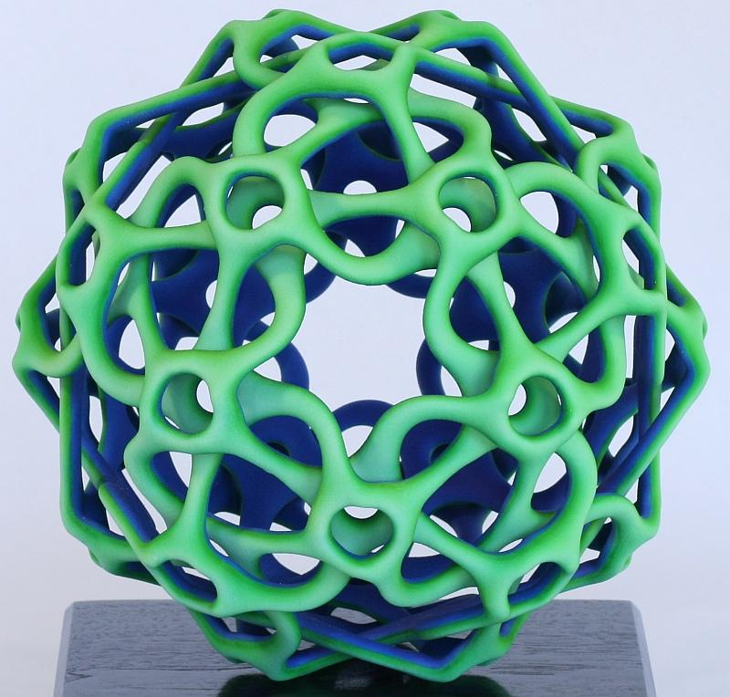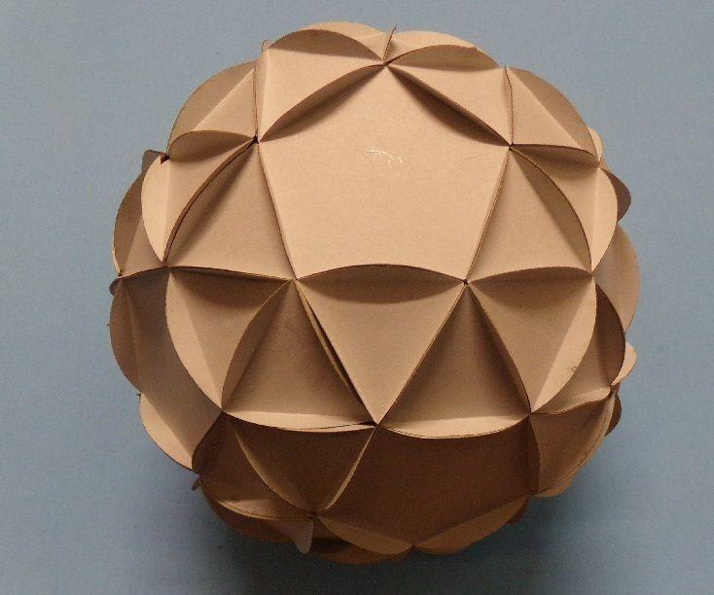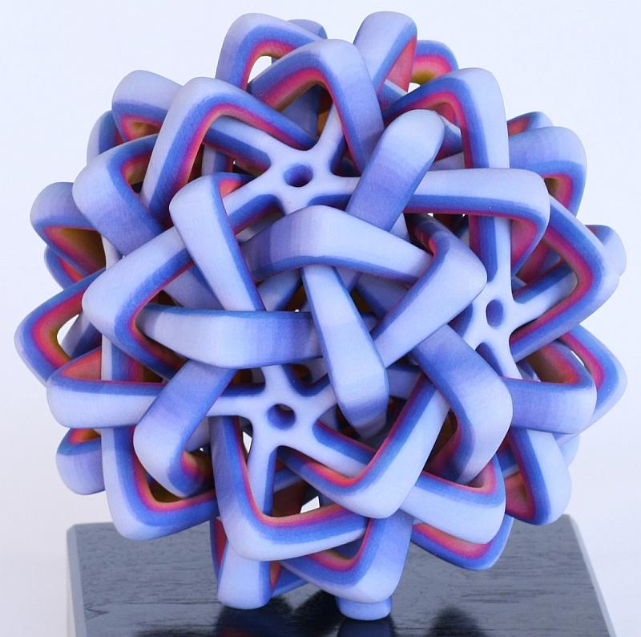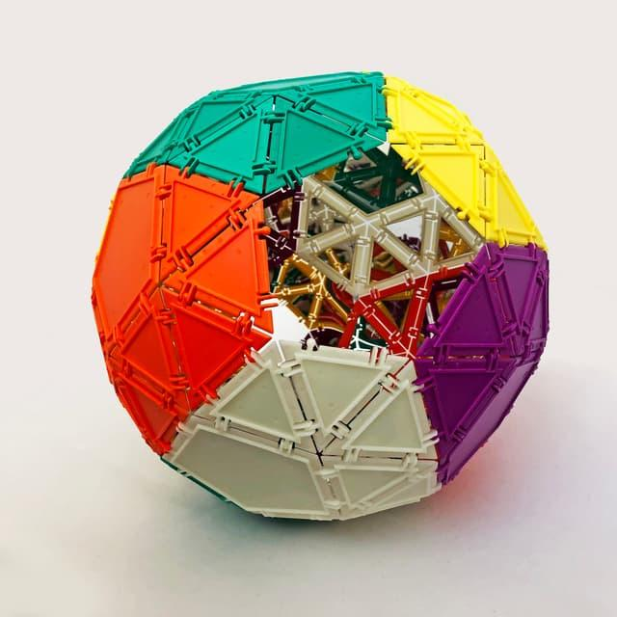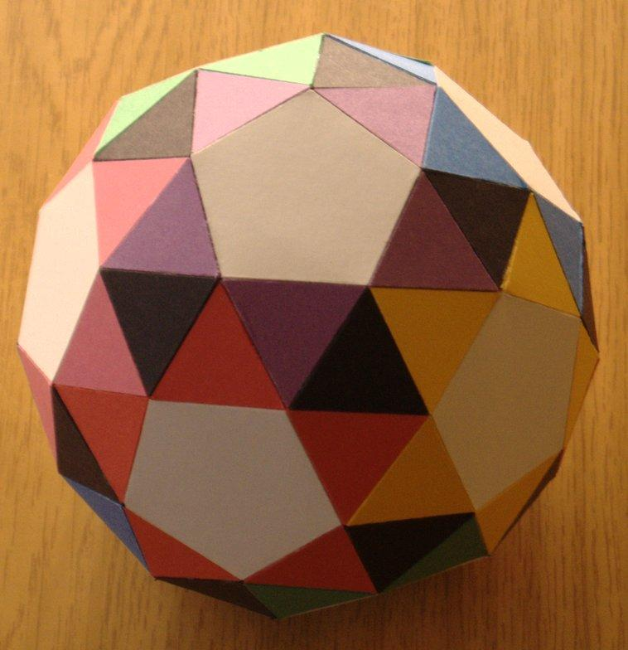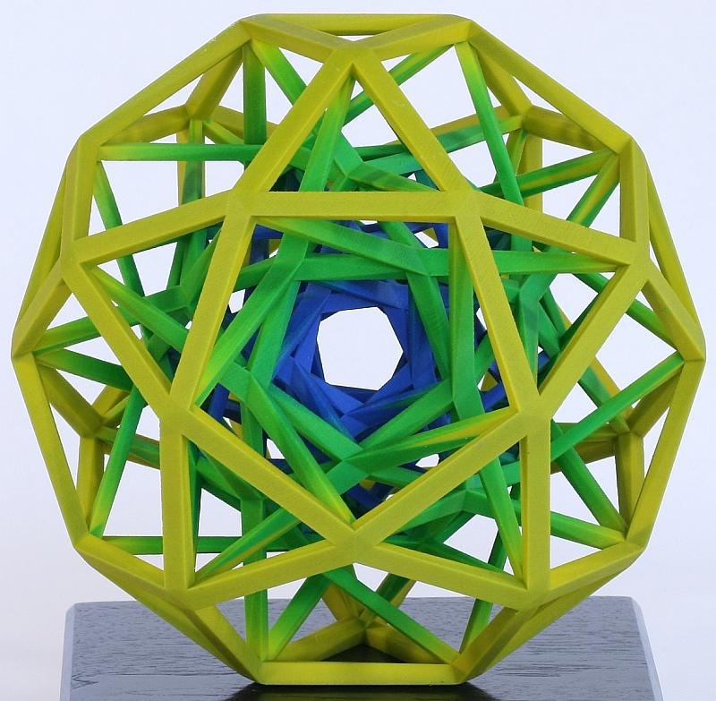

Relationship to Other Geometric Solids
# Source: AI Source: Provided by: [Data Path: Persons Table -> ID Column: 1, Name_En Column: Motasem Essam] -> From: [ChatGPT] on [7/25/2026]
Dual Polyhedron
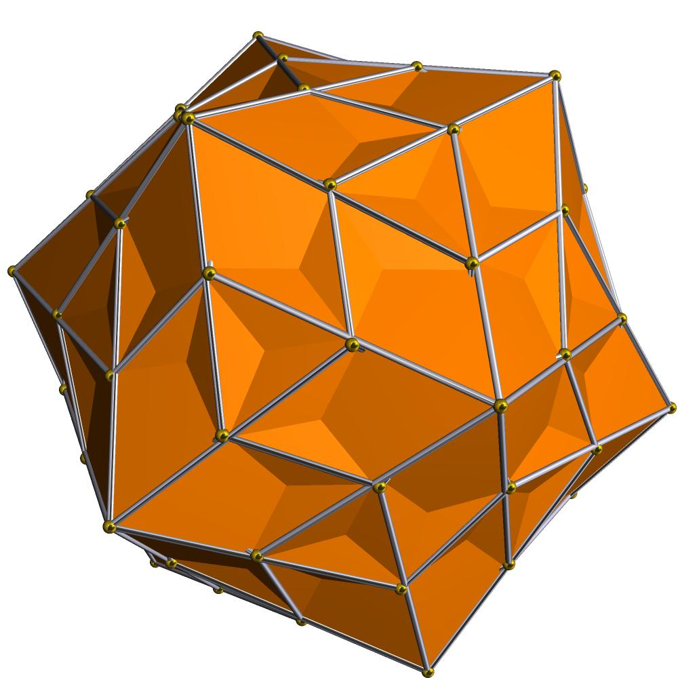
Medial Pentagonal Hexecontahedron
The dual of the Snub Dodecadodecahedron. Its vertices correspond to the original polyhedron's faces, and its faces correspond to the original polyhedron's vertices.
Related Polyhedra
- Dodecadodecahedron: A related uniform star polyhedron containing pentagonal and pentagrammic faces.
- Great Dodecahedron: A related Kepler–Poinsot polyhedron with pentagrammic faces.
- Snub Dodecahedron: A convex Archimedean solid with a related snub construction, but a different face composition and symmetry structure.

Comparison with Related Solids
# Source: AI Source: Provided by: [Data Path: Persons Table -> ID Column: 1, Name_En Column: Motasem Essam] -> From: [ChatGPT] on [7/25/2026]
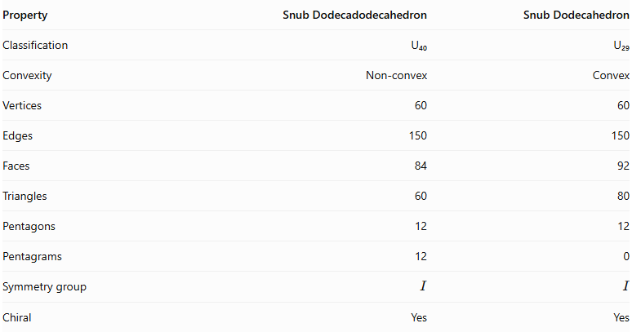
Property | Snub Dodecadodecahedron | Snub Dodecahedron
Classification | U₄₀ | U₂₉
Convexity | Non-convex | Convex
Vertices | 60 | 60
Edges | 150 | 150
Faces | 84 | 92
Triangles | 60 | 80
Pentagons | 12 | 12
Pentagrams | 12 | 0
Symmetry group | $$I$$ | $$I$$
Chiral | Yes | Yes
The principal difference is that the Snub Dodecadodecahedron contains 12 pentagrammic faces, while the Snub Dodecahedron contains only ordinary triangles and pentagons.

Main Classification
# Source: AI Source: Provided by: [Data Path: Persons Table -> ID Column: 1, Name_En Column: Motasem Essam] -> From: [ChatGPT] on [7/25/2026]
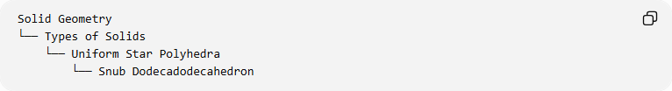
Solid Geometry
└── Types of Solids
└── Uniform Star Polyhedra
└── Snub Dodecadodecahedron

Key Points
# Source: AI Source: Provided by: [Data Path: Persons Table -> ID Column: 1, Name_En Column: Motasem Essam] -> From: [ChatGPT] on [7/25/2026]
- The Snub Dodecadodecahedron is a non-convex uniform star polyhedron.
- It contains 60 triangular faces, 12 pentagonal faces, and 12 pentagrams.
- It has 84 faces, 150 edges, and 60 vertices.
- Its vertex configuration is $3.3.\frac{5}{2}.3.5$.
- Its Wythoff symbol is $| 2 \frac{5}{2} 5$.
- Its symmetry group is the chiral icosahedral group $I$.
- It exists in left-handed and right-handed forms.
- Its dual is the Medial Pentagonal Hexecontahedron.
- Its Euler characteristic is $-6$.

Conclusion
# Source: AI Source: Provided by: [Data Path: Persons Table -> ID Column: 1, Name_En Column: Motasem Essam] -> From: [ChatGPT] on [7/25/2026]
The Snub Dodecadodecahedron is a distinctive member of the uniform star polyhedra, combining triangular, pentagonal, and pentagrammic faces in a chiral non-convex structure. Its icosahedral rotational symmetry, uniform vertex arrangement, and dual relationship make it an important example of snub constructions in three-dimensional geometry.

